**VET Student Loan Information and Obligations**

**What is VET Student Loans?**

VET Student Loans is a loan from the Commonwealth, which was introduced in January 2017. This loan will remain a personal debt until repaid; until then your loan may reduce your borrowing capacity and may reduce your take home income (after tax) until you have repaid the debt in full.

You may wish to seek independent financial advice before applying for VET Student Loans.  
VET Student Loans allows eligible students to access higher level VET qualifications, particularly those students who could not otherwise afford to pay upfront.

**Eligibility**

There are specific criteria students must meet to be eligible for a loan through VET Student Loans. Students must have been assessed as academically suited to undertake the eligible course and their HELP balance must be greater than zero. Furthermore, a student must be:

* an Australian citizen; or
* the holder of a permanent humanitarian visa who is usually resident in Australia; or
* a [qualifying New Zealand citizen](http://studyassist.gov.au/sites/studyassist/helpfulresources/pages/faqs-nz)

**Loan Caps**

* Eligible students will be entitled for loans up to a capped amount of:

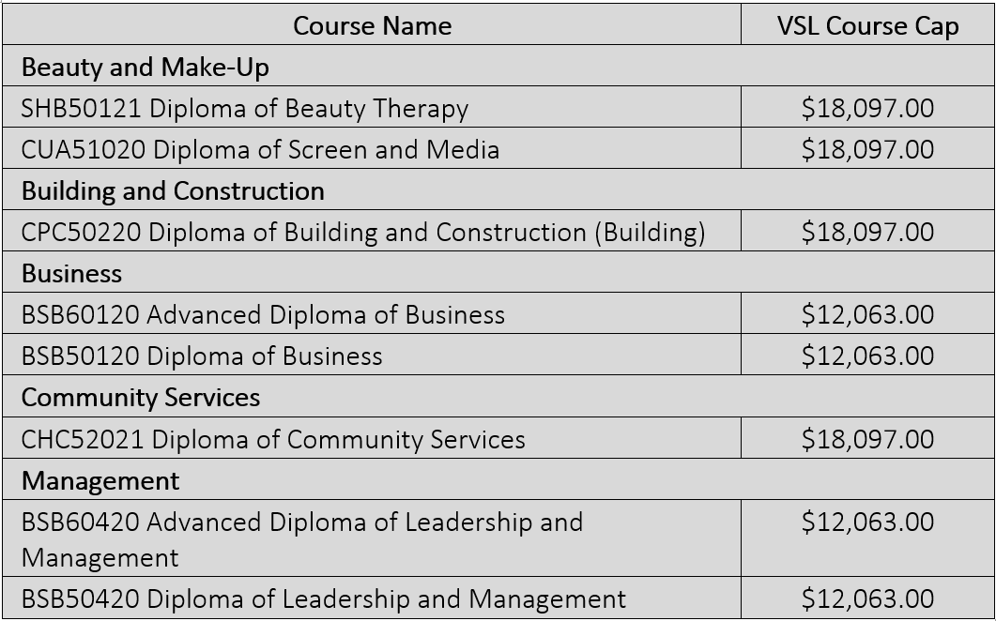

* Providers may charge above this cap for a course, and if so, students will be expected to pay for the difference according to the provider’s billing period.

**Repayment**

* Repaying the loan is required when your income reaches the repayment threshold.
* The maximum loan amount you can borrow from the Australian Government is $121,844.

**Engagement**

* You will be required to demonstrate you are progressing throughout your course.
* You will be required to log in online and acknowledge that you accept the loan you will receive for the course.

**Applying**

We will assist you in applying by confirming your eligibility and providing you with the VET Student Loan information sheet, VSL Information for Students booklet and application forms prior to completing your enrolment. To apply for a VET Student Loan you must complete the Request for a VET Student Loan electronic Commonwealth Assistance Form (eCAF) by the census day. See point 3 of the VSL Information for Students booklet for more information.

**Fees and Charges**There is no application fee for requesting VET Student Loans.There is a 20% loan fee which is applied to the loan. The loan fee does not count towards your FEE-HELP limit. The loan fee is 20% of the tuition fees charged for your units of study – and it is calculated for each individual unit of study as you undertake your course.

**How do you repay the loan?**Your debt is repaid through the tax system. In the 2023-2024 income year, you will be required to make a compulsory repayment if your income is $51,550 or above.

**VET Student Loans (VSL)/VET FEE HELP (VFH) Tuition Assurance**

A full statement of tuition assurance for VET Student Loans and VET FEE HELP can be found on the college website [www.perthcollege.com.au](http://www.perthcollege.com.au) and is available at any time by request in the office. These statements provide information in relation to fees paid and how arrangements will be made for students in the unlikely event that a Perth College of Beauty Therapy course ceases to be provided after it starts but before it is completed. For more information please refer to the full statements on the home page of the PCBT Website.

**I have read and understand the VET Student Loan and conditions above. I understand this is a loan and needs to be repaid with a 20% loan fee added on and may reduce my borrowing capacity until the debt is repaid.**

Applicant Name: ____________________________________________

Signature of applicant: _______________________________________ Date: __________ Time: __________

If Under 18

Parent/Guardian Name: ______________________________________   
Signature of Parent/Guardian: _________________________________Date: __________ Time: __________